HINDUSTANI VOCAL CONCERT
BY
NACHIKETA SHARMA
June 15, 2007 at 7 p.m.
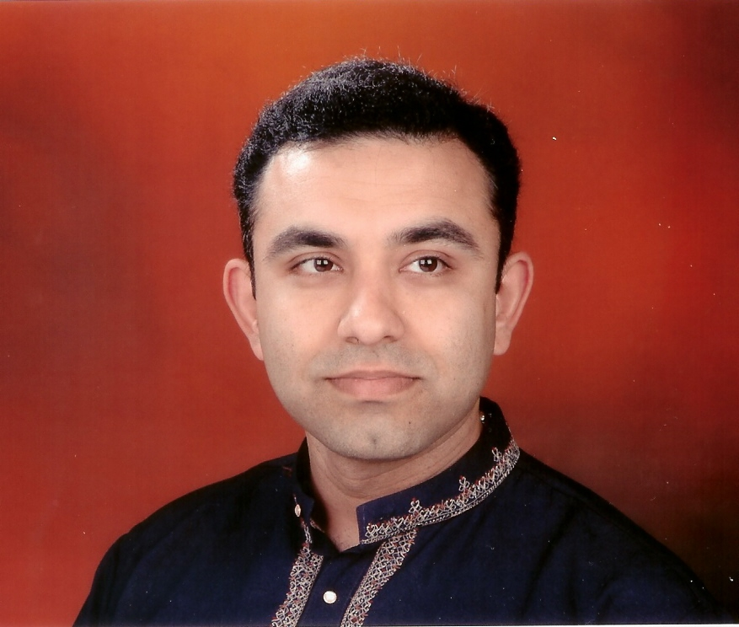
Harmonium: Vivek Datar
Tabla: Ravi Gutala
Venue: Mitralaya
19306 Pinnacle Ct.
Saratoga, CA 95070

Contact: Anu Singh at 408 839-6149 or mitralaya@gmail.com

*PLEASE ARRIVE ON TIME. THIS CONCERT IS FREE OF CHARGE*

